

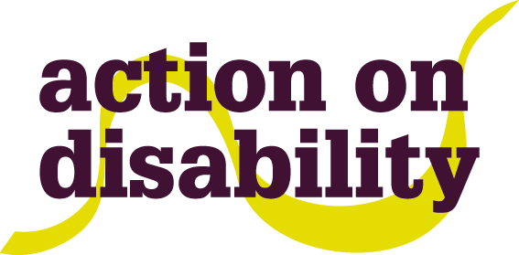
Join us to Celebrate
International Day of Disabled People
On Thursday 3rd December 2015

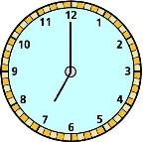
4.30 – 7.00pm
At
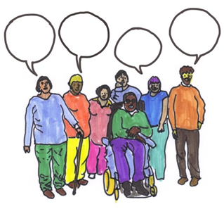
Hammersmith & Fulham Town Hall, Small Hall, King Street, London, W6 9JU

The theme for this year is “Inclusion matters: access and empowerment of people of all abilities! So come along and be part of a lively debate followed by music and performance!
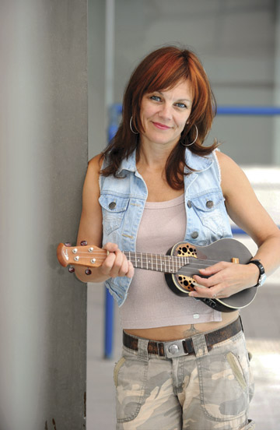

Entertainment: Liz Bentley (comedian/singer)

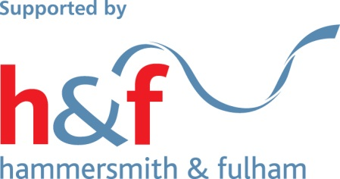
To book a place contact HAFCAC on 0208 960 8888 x 21or e- mail info@hafcac.org.uk by Thursday 26th November. Let us know if you have any access needs. There will be BSL signers and a speech to text typist.

